Practical - 7
Practical Title: PHP Form Processing with Server-Side Validation and CSV/JSON File Storage
Problem Definition : Process submitted registration/contact form data using PHP. Validate and sanitize inputs on the server side and store records in CSV or JSON file format. Display success/error messages.
1. Is the form submitted using POST?
Answer: Yes. The form uses method="POST" and action="process.php". POST sends the data in the request body, not in the URL. This keeps details like email and password out of the address bar and browser history, and it has no small size limit like GET. In PHP I also check $_SERVER["REQUEST_METHOD"] === "POST" so the script only runs when the form was really submitted. The values are read from $_POST.
2. Are inputs validated and sanitized server side?
Answer: Yes. Client-side validation can be bypassed, so PHP checks everything again.
- Validation:
  - empty() checks that required fields are filled.
  - filter_var($email, FILTER_VALIDATE_EMAIL) checks the email.
  - preg_match() checks the mobile number (10 digits) and the name (letters only).
  - strlen() checks the password length.
3. Is file writing handled safely?
Answer: Yes.
- I only write data that has already passed validation and sanitization.
- I use fopen() in append mode ("a") with fputcsv() for CSV. For JSON, I read the old file, decode it, add the new record, and write it back with json_encode().
- I use flock() to lock the file, so two users submitting together do not corrupt it.
- I check that the file opened successfully before writing.
4. Are success and error responses displayed clearly?
Answer: Yes. If validation fails, the page shows a red error message next to each wrong field, and the correct values stay filled in so the user does not retype everything. If saving works, the page shows a green message such as "Registration successful!". If file writing fails, it shows "Something went wrong, please try again." I also use a redirect after success, so refreshing the page does not submit the form twice.

B. Implementation / Output / Result
<!DOCTYPE html>
<html>
<body>
<h2>Registration</h2>
<form method="POST" action="process.php">
Name: <input type="text" name="name"><br><br>
Email: <input type="text" name="email"><br><br>
Mobile: <input type="text" name="mobile"><br><br>
Password: <input type="password" name="password"><br><br>
<button type="submit">Register</button>
</form>
</body>
</html>

C. Evidence of Work (Screenshots)

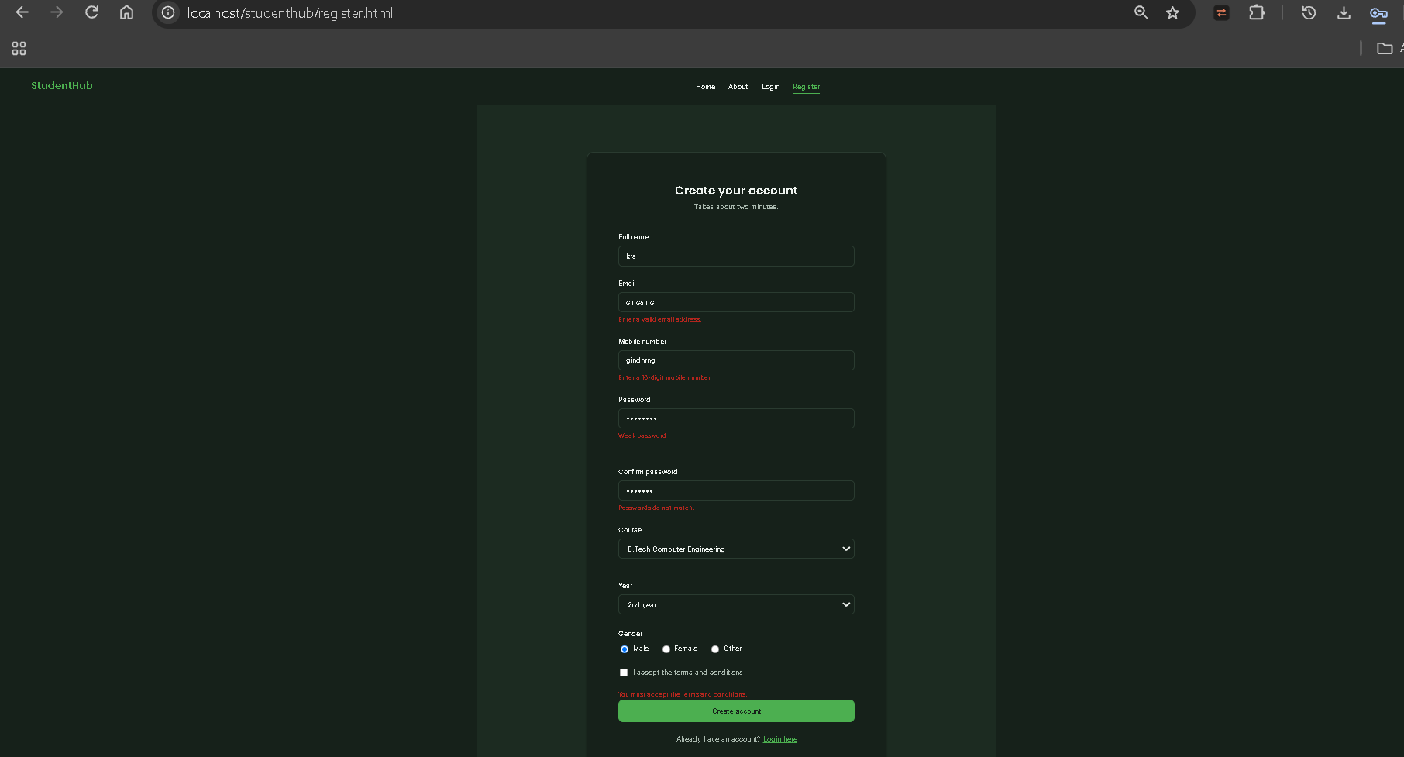

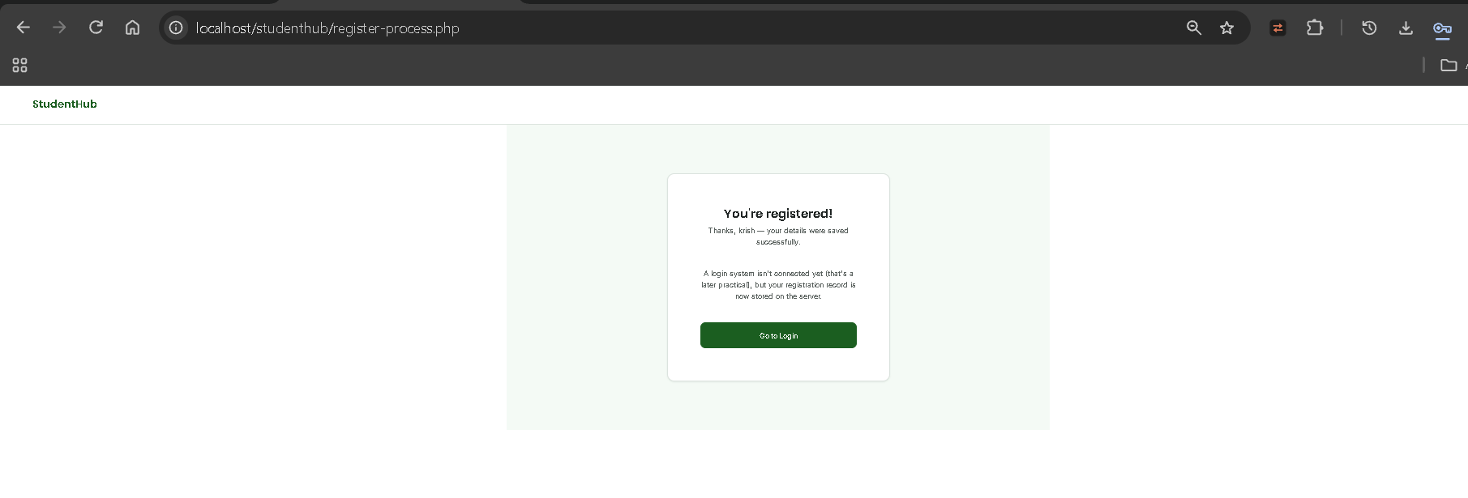

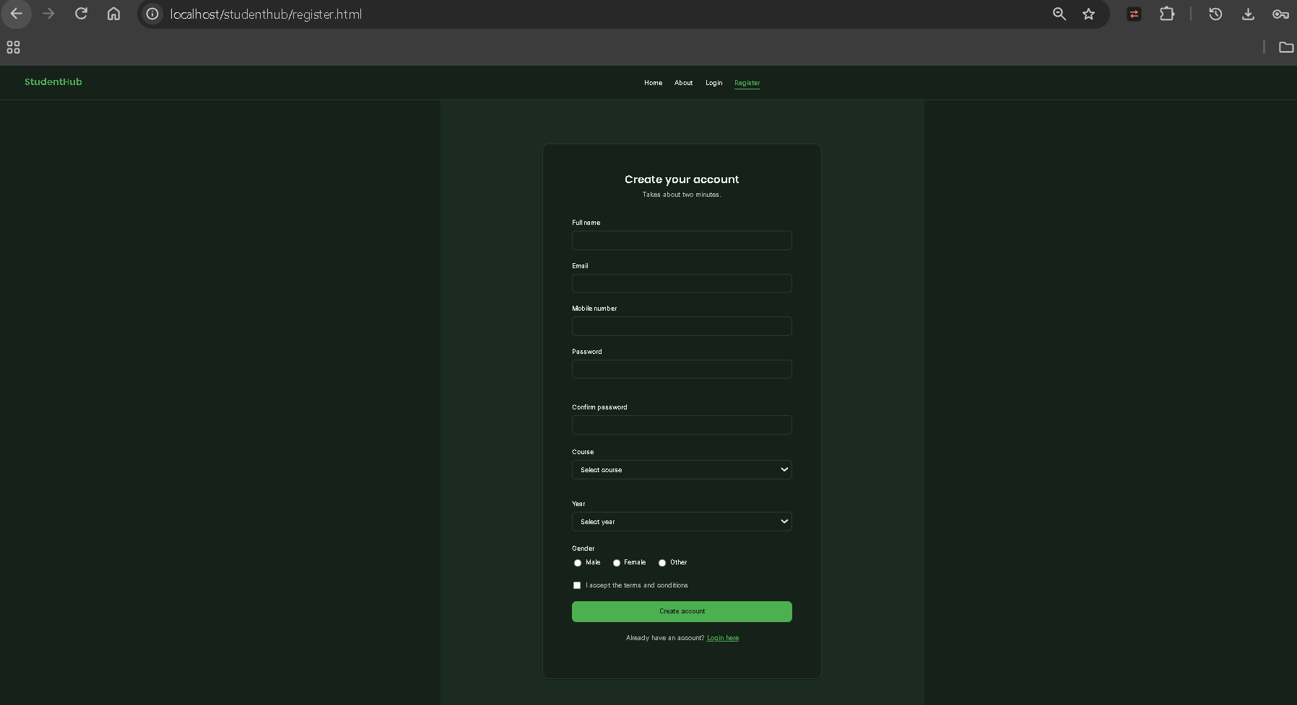

D. GitHub Repository Link :

https://github.com/kvvaghasiya49/Web_Development.git

E. Challenges Faced:
- XAMPP setup: Apache did not start because port 80 was already in use. I changed the port or stopped the other program.
- File not found / 404: the project was not inside the htdocs folder. I moved it there and opened it through localhost.
- CSV or JSON file was not created because of folder permission problems. I fixed it by making the data folder writable.
- $_POST was empty because the name attribute was missing on some inputs. I added it.

F. Learning Outcomes:
- I can process form data in PHP using POST and $_POST.
- I understand why server-side validation is necessary even when client-side validation exists.
- I can validate and sanitize input using filter_var, preg_match, trim, and htmlspecialchars.
- I can store data safely in CSV and JSON files using fputcsv, json_encode, and flock.

G. Faculty Remarks:

